Our Extra-Sensory Selves:
A Development Circle In Experimental Mediumship

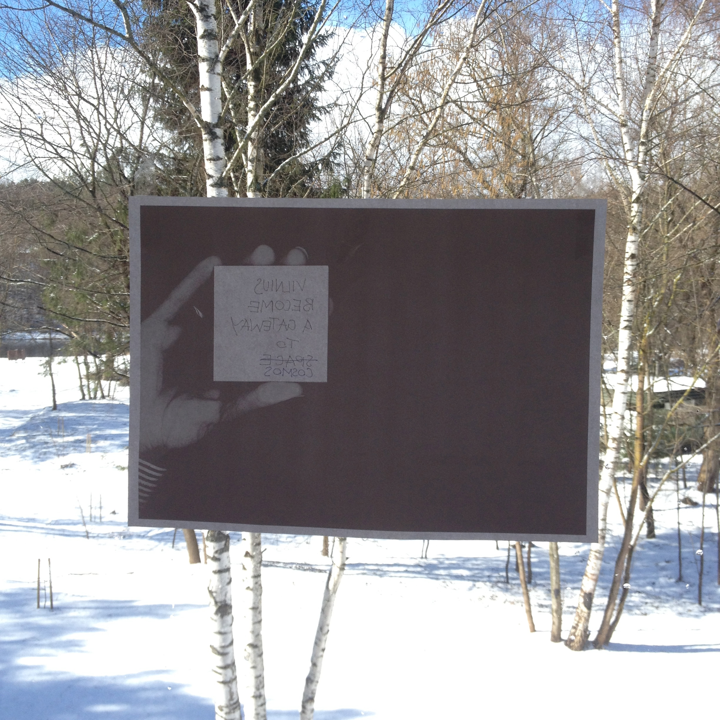

Whilst at Rupert, resident Allison Gibbs is becoming mediumistic as a methodology; by attempting to learn and embody the sensibilities and practices of a medium to consider extra-sensory practice as a mode of radical, transitory subjectivity and to channel, for example, the geographical centre of Europe and Jonas Mekas via physic phenomena. What's a medium? It's an intermediate agency, a channel of communication or substance through which something is transferred. It's also a person who conveys information from external, metaphysical entities such as spirits, incorporeal personal agents or non-human energies, animals or objects.

But when something is channelled where does the distinction between the channeller and the channelled, the internal and the external, the subject and the object lie, of there is a distinction at all? If you channel it, do you become it? And if you become it where does you go at moment of communication?

Our Extra-Sensory Selves: A development circle in experimental mediumship will operate as a group workshop to test out theories and experiences of transitory subjectivity and extra-sensory knowledge production by deploying the strategies of the psychic spirit medium.

The Development Circle will run for two sessions. The first session will be based in the studio at Rupert and second session will be based off-site, at Radžiuliai, Purnuškės (the geographic centre of Europe). Both sessions will involve discussion and practical exercises (similar to meditation). No prior psychic experience is required.

What is Mediumship?
Mediumship traditionally involves deploying an extra-sensory, psychical and clairvoyant ability to channel information from external, metaphysical entities such as spirits, incorporeal personal agents or other energies. Mediumship can occur both mentally and physically and generally involves the Medium entering a state of altered consciousness in order “make way” for something external to be received. Mediumistic phenomena have been practiced and recorded, with varying degrees of social acceptability throughout human history.

What is Experimental Mediumship?
Experimental Mediumship is a form of mediumship practiced without privileging the intentions regularly associated with traditional forms of spirit mediumship, for example, the practice of mediumship as an evidentiary tool for proof of survival , as a service for the bereaved, as a form orthodox religion, as a financial enterprise, as stage-entertainment. Experimental Mediumship attempts to produce no capital value. The value of Experimental Mediumship, what it's for, is determined by the individual/group who practices it. Perhaps it's for curiosity, for receiving and making a different kind of knowledge, for temporarily becoming something other than oneself, for getting some extra senses. Experimental Mediumship is practiced out of an interest in transitory and fugitive subjectivity. It's practiced with seriousness and dedication. It's not interested in being ironic or reactive.

What is a development circle?
The development circle is a non-hierarchical platform for shared extra-sensory advancement. The circle is a kind of psychical classroom for intuitive collaborative study, where we will be learning about what might constitute “spirit”, altered states and extra-sensory phenomena and practices. The circle contends that the way to remove the self in order to channel something other than the self, is with others. The development circle will involve discussion and practical exercises to attempt to expand consciousness, raise vibrations and link to external “spirit” to receive and convey something. Practical exercises are similar to meditation.

Are there any risks involved?
It is normal for some to feel as sense of anxiety when attempting to develop extra-sensory abilities and connect to things external to the self. Some might fear that they will be possessed or become completely dissociated from the self. This is highly unlikely. During channelling we may feel, see or hear things which we might not have experienced before. During the early stages of an experimental medium's development this will most likely be produced by their own subconscious mind rather than be any external influence. Experimental Mediumship poses no intentional risk.

Is Our Extra-Sensory Selves for me?
If you are interested in the potential of expanding consciousness, developing extra-sensory aptitude, being a recipient and mode of transference of external information and experiencing transitory or fugitive subjectivity, then Our Extra-Sensory Selves is right for you.This Experimental Mediumship development circle is suited to those who are looking to explore potentiality rather than outcome, process rather than product. Mediumship can be a personally challenging process during which we learn about ourselves and are required to sort our own mental and emotional garbage. If you feel you are not ready to do this , if you feel vulnerable in anyway or uncomfortable with the idea of experiencing psychical phenomena perhaps Our Extra-Sensory Selves isn't suitable for you.

Can I practice Experimental Mediumship independently afterwards?
Yes.
Allison (b.1978, Penrith, AUS) graduated with a Masters of Fine Art from The Glasgow School of Art in 2013, with an exchange at The Piet Zwart Institute Rotterdam, NL. She is currently based in Glasgow.

Working predominantly with 16mm film, video and writing, Allison devises methodologies for making by translating things into actions; like a constellation, a table or a psychic medium as a way of channeling and representing multiple points of theoretical, anecdotal, historical and visual reference.

Forthcoming projects include Kelly, a collaborative exhibition with Jennifer Bailey, Tessa Lynch & Thorgerdur Olafsdottir for Glasgow International 2014, an adaptation of the recent scripted film work Spirits of Ecstasy (Murnau's Death Mask) for The Happy Hypocrite – Heat Island (issue 7, summer 2014) guest edited by Isla Leaver-Yap and a residency at Hospitalfield Arts, Arbroath, Scotland. Recent exhibitions include SPIRIT SHADOW SPECTRE BONES and PHANTOM, Intermedia, CCA Glasgow, Fall Scenes, 134 Renfrew St Glasgow and GSA MFA Graduate Exhibition, The Glue Factory, Glasgow.

Bryan Reynolds defines the fugitive subject in the following way; “Breaking from semiotic-semantic systems dictated by state machinery, fugitive subjects elude static definitions of social identity and self through subjunctive and transversal movements. Due to the inherently chaotic nature of such actions, fugitive subjects may act without apparent motivation or guidance”. Reynolds, Bryan. Transversal Subjects; from Montaigne to Deleuze after Derrida. 2009; Palgrave Macmillian, UK. P.278.

